**Configuration Guide for AWS EKS integration with AWS code pipeline.:**

**Required tools and Services:**

1. AWS account, GitHub Account (code commit).
2. Docker based application source code.

https://github.com/vamsi-devops/Insecure-banks.

1. Services used in AWS is (ECS, ECR, IAM, Code Build, Code Deploy, Code Pipeline).

Contents

**1** **EKS Setup:**

1.1 Create IAM User & VPC: 7

1.2 Create repository in ECR. 8

**2** **CI/CD implementation:**

2.1 Code Build 12

2.1.1 Push image to ECR.

2.2 Create Ec2 instance …………………………………………………………………………………………………….13

2.3 Code Deploy. 17

2.4 Code Pipeline ……………………………………………………………………………………………………………21

2.5 EKS Cluster formation………………………………………………………………………………………………….22

2.6 Output…………………………………………………………………………………………………………………………23

* 1. **VPC & IAM User Creation:**

🡪 **VPC CREATION STEP BY STEP**

By default, if we create the VPC we will get

1. Route Table
2. NACL
3. SG (security group)

STEP1:

* Assign a tag name for VPC
* Take CIDR value as per your requirement (ex: 192.168.0.0/16)
* VPC has been created as per the requirement

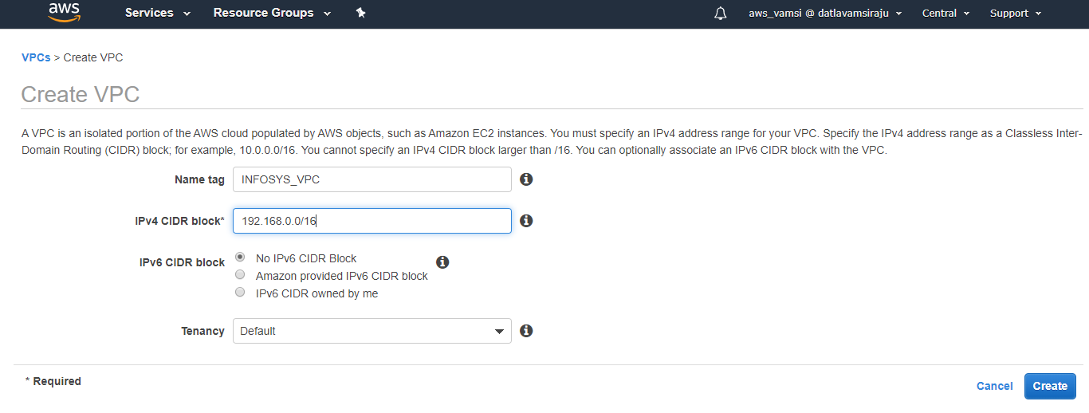



STEP2:

* Create IGW and assign a tag name.

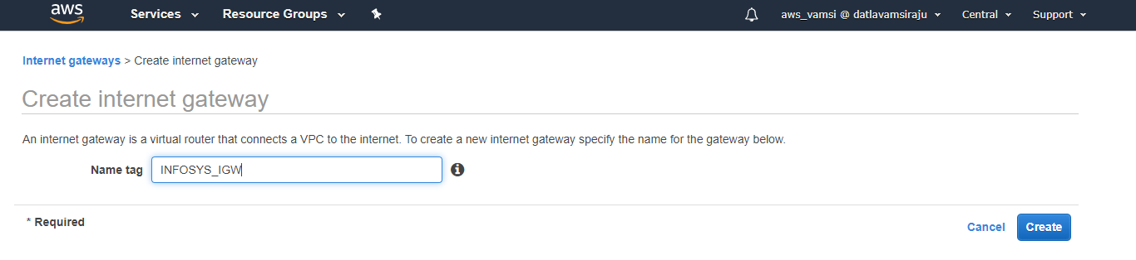



STEP3:

* Attach IGW to VPC to give public access to the VPC.

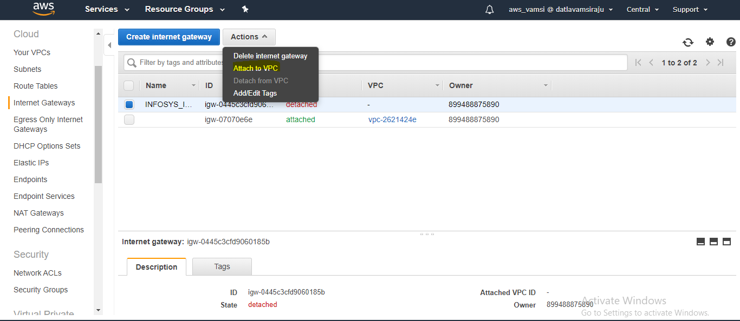



STEP4:

* IGW has been attached to the VPC.
* Now the isolated VPC has been exposed to public.

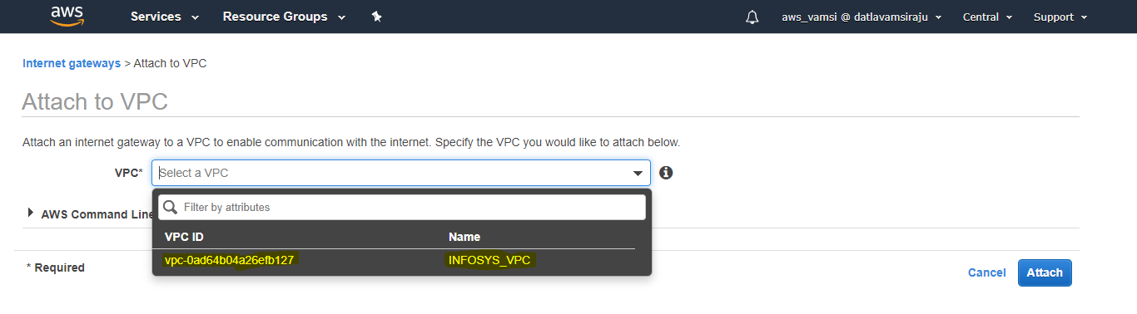



STEP5:

* After VPC creation and IGW attached to the VPC we have to create the SUBNET’S

1st subnet is for public

2nd subnet is for private

* The below are the required details for creating SUBNET1 well as SUBNET2

SUBNET1:

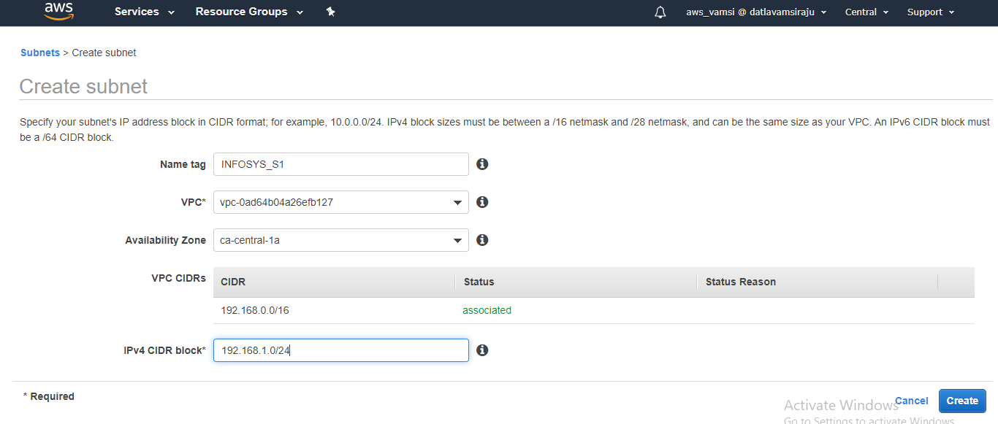



SUBNET2:

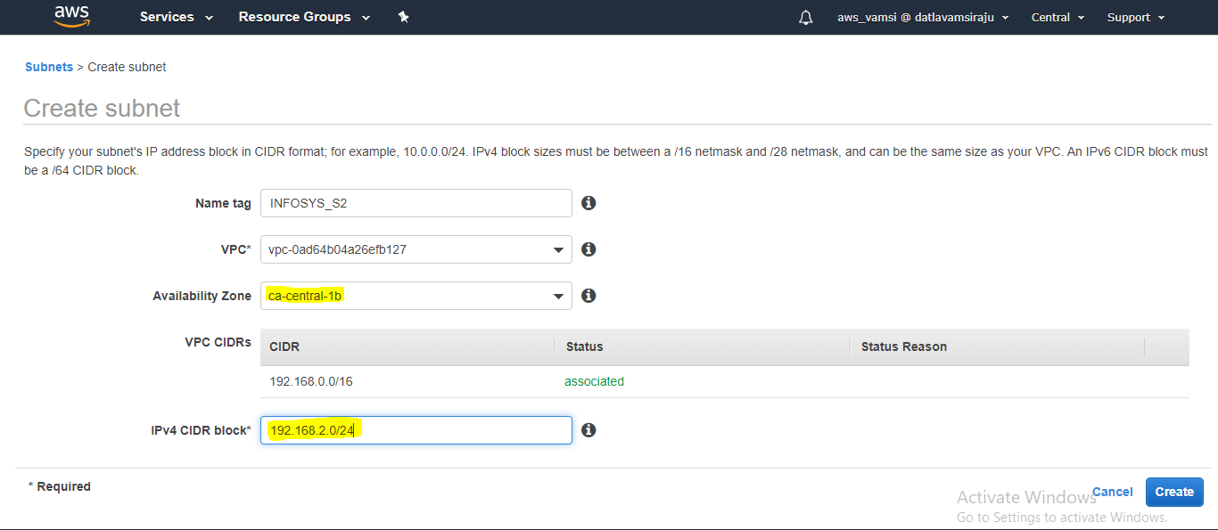



STEP6:

* Assign SUBNET to the Route table.

1. Subnet1 is assigned to public route table.
2. Subnet2 is assigned to private route table.

Public route table assigned to public subnet:

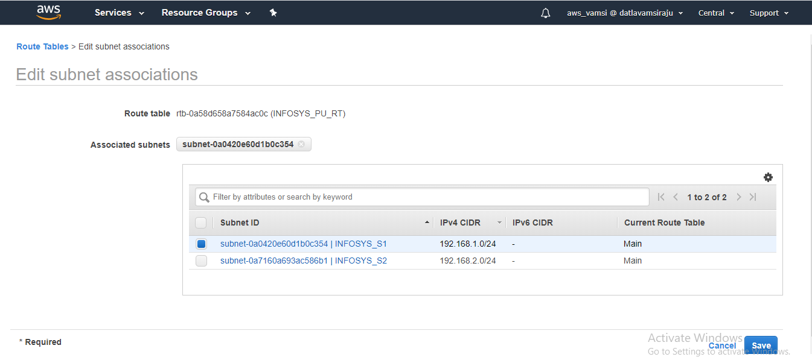



Private route table assigned to private subnet:

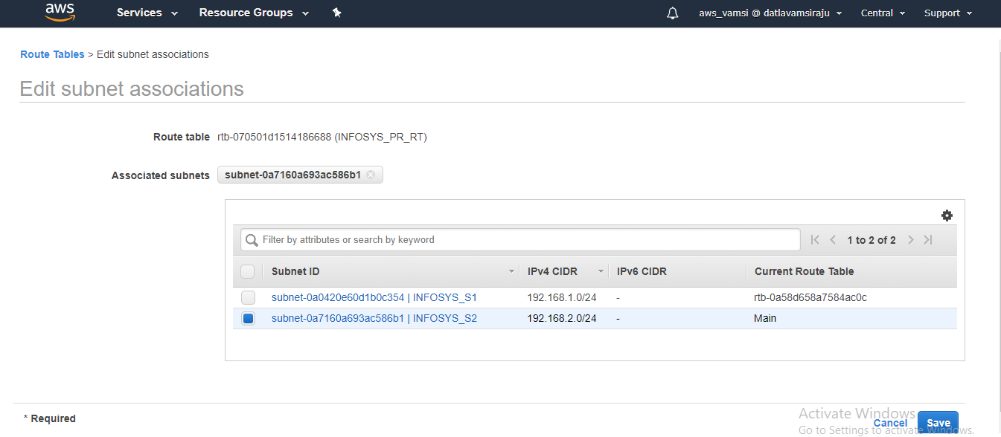



STEP7:

* Need to attach IGW to Route table.
* Only when you attach IGW then the Route table and attached Subnet will act as public.

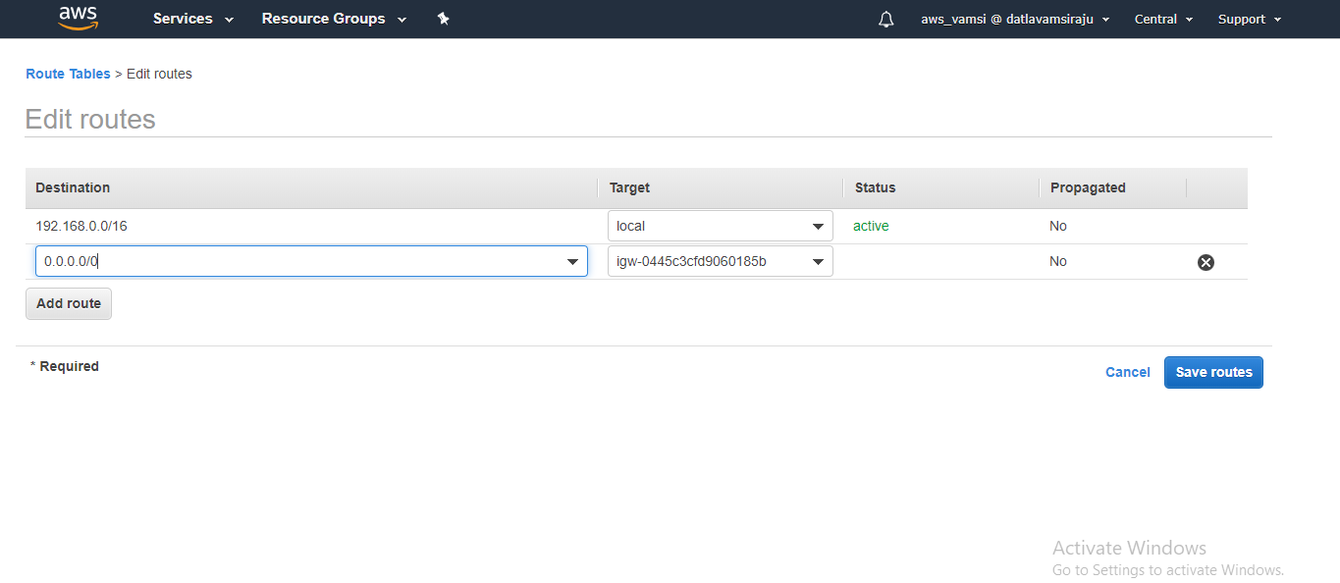



STEP8:

* NAT gate way is a bridge between Private Route table and internet.
* Once NAT is connected to the route table the private route table will be connected to internet.

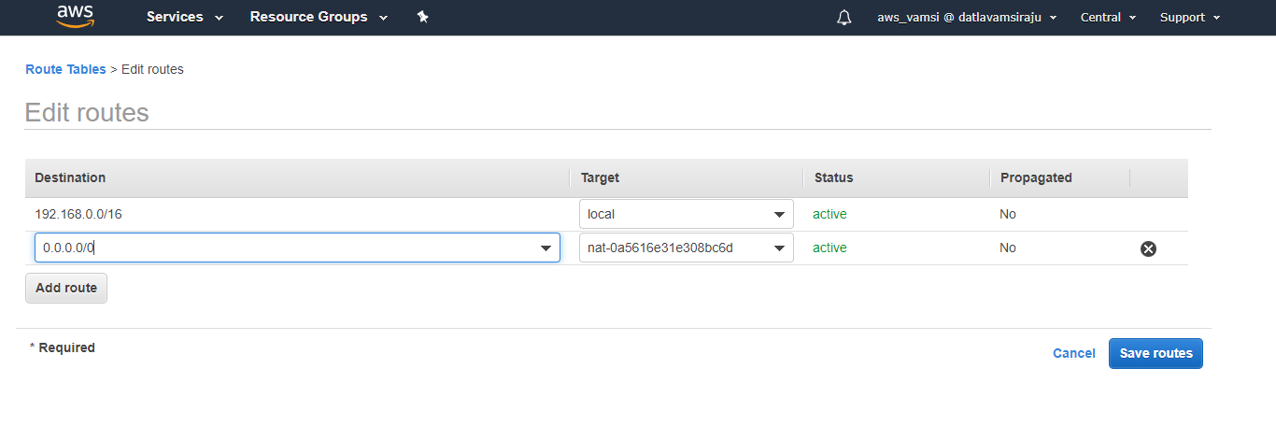



* 1. **Create an ECR repository:**

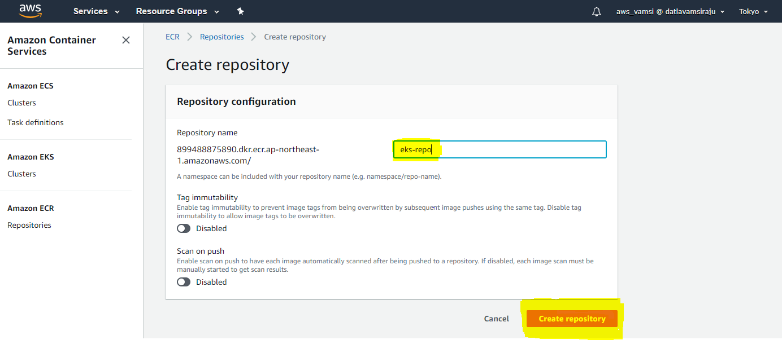



Give a name to ECR repository and create it in my case I have given EKS-repo.

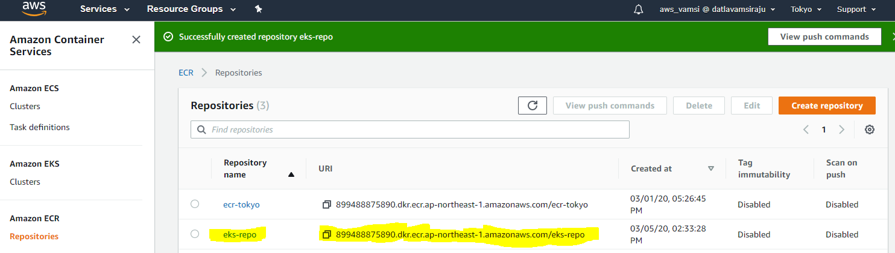



* After creating ECR Repository create a Build project in Code Build

Create build project.

**2.1 Code Build:**

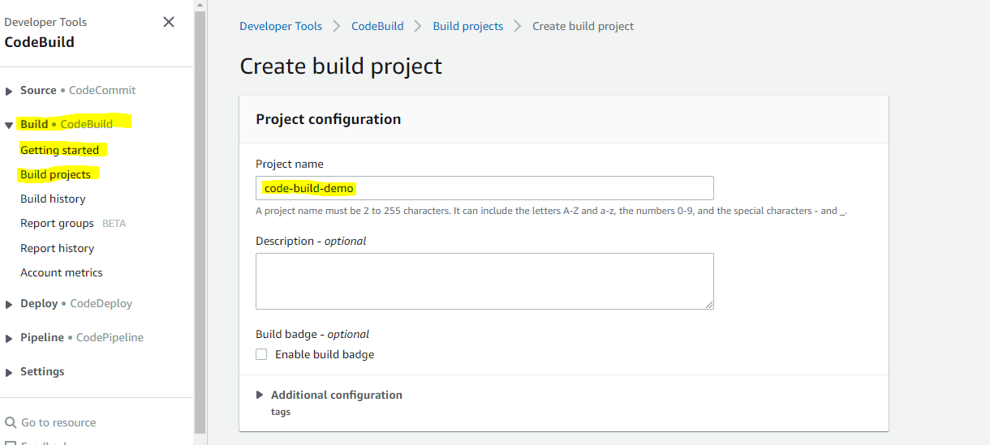

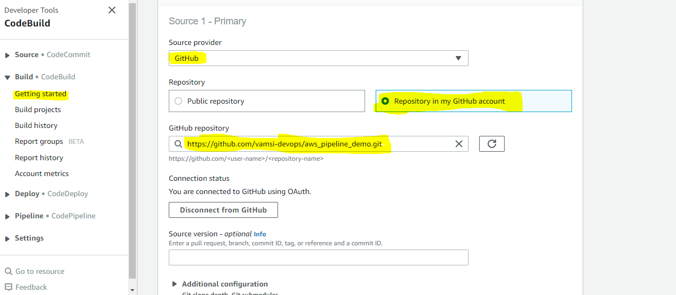

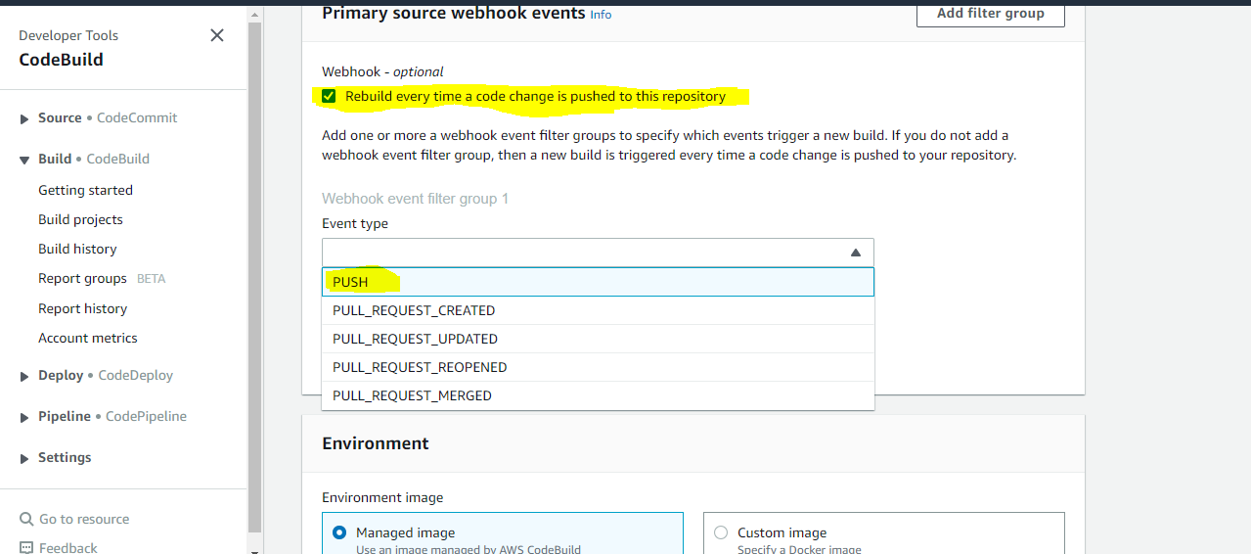

Here we will give a Debian/RedHat instance for building the image.

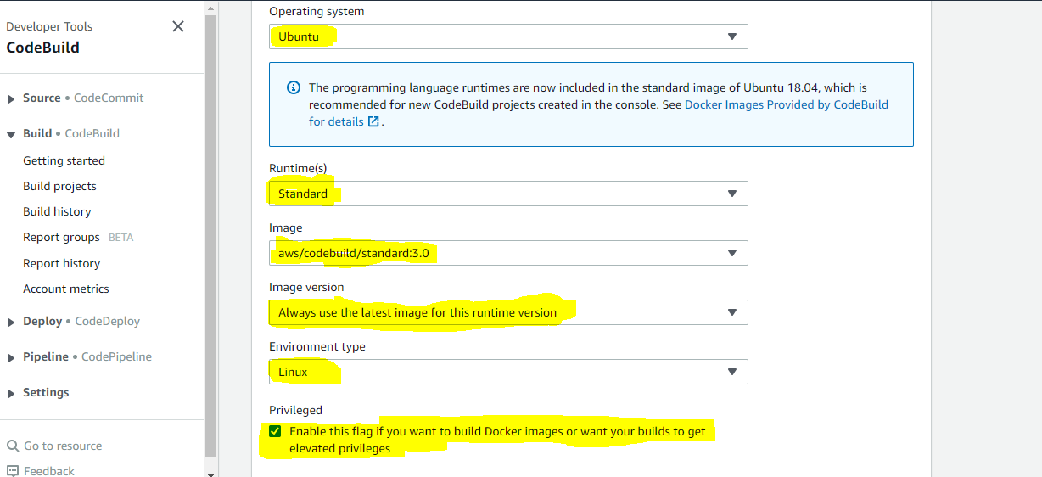

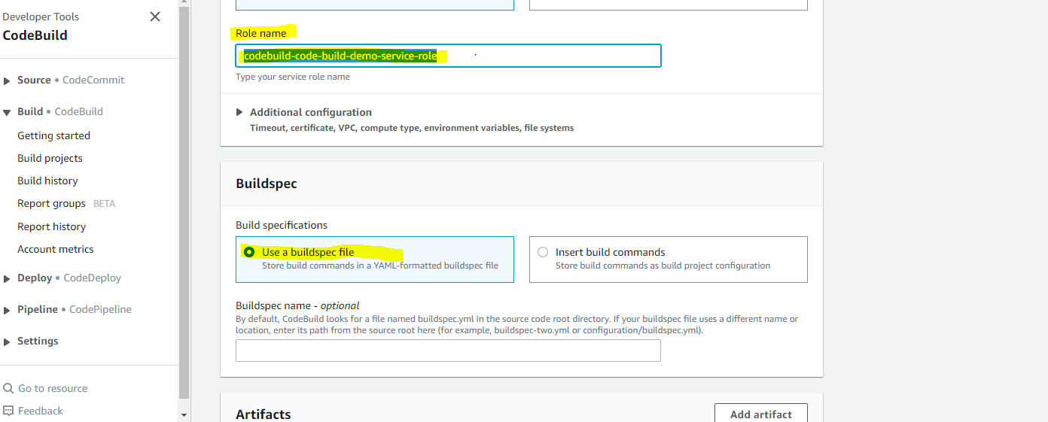

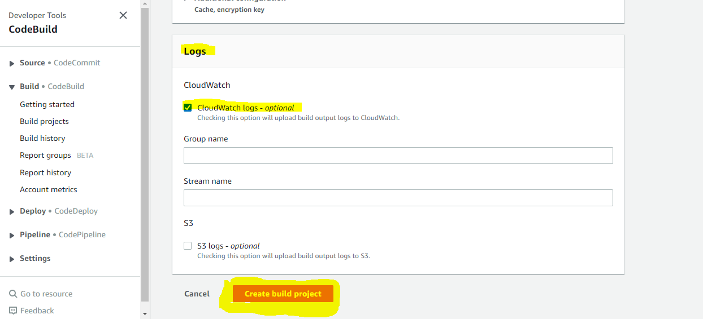

Successfully created a Code Build.

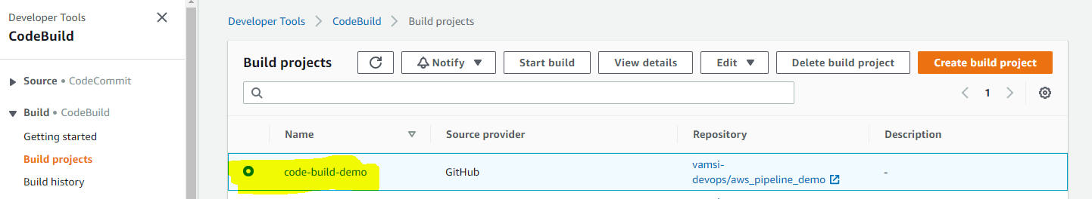

* Create a same IAM role which you given in Code build and attach a AmazonEC2ContainerRegistryFullAccess Policy to the service role for pushing the images into the ECR registry.

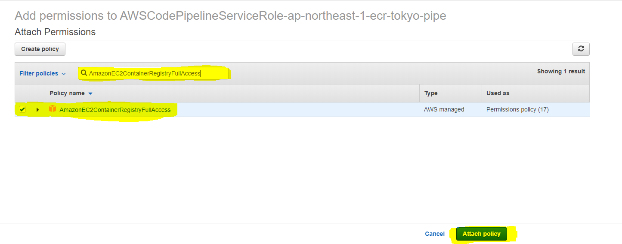

**2.2 Create an Ec2 Ubuntu Instance and make sure to Install AWS CLI 2.0 & Ruby:**

 Install the Code Deploy agent on the node now by following the below steps:

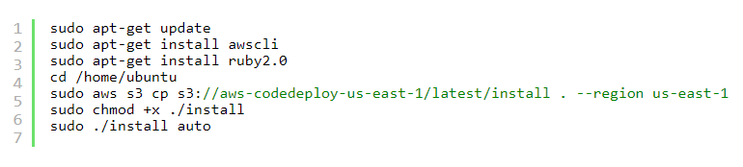

* And create IAM role and attach full Administrator access policy to the role and attach that role to the instance.

🡪 To check whether the Code Deploy agent working or not.

# sudo service codedeploy-agent status

**2.3 Create a Code Deploy:**

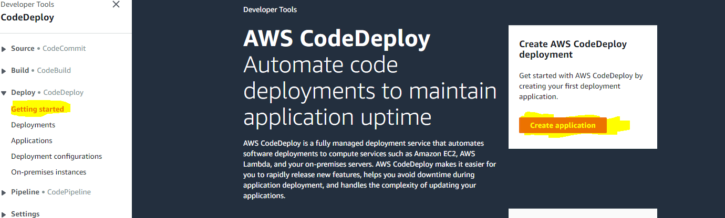

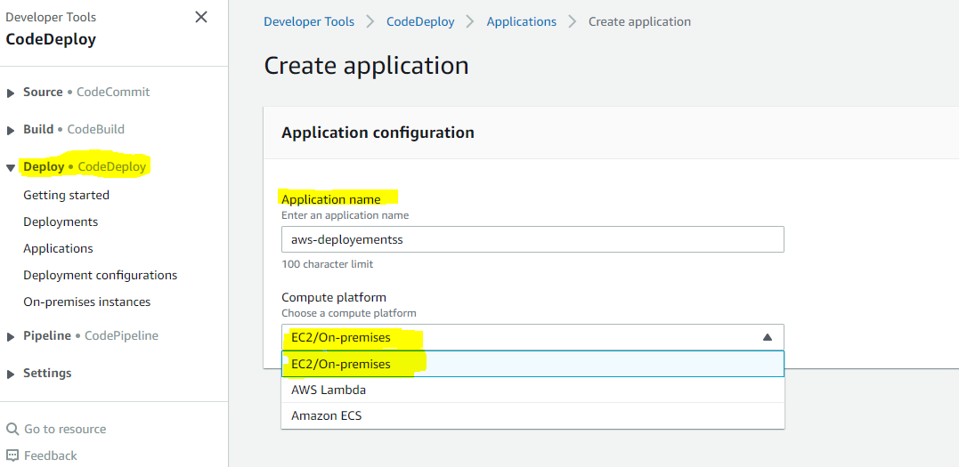

* After creating Application create the deployment group.

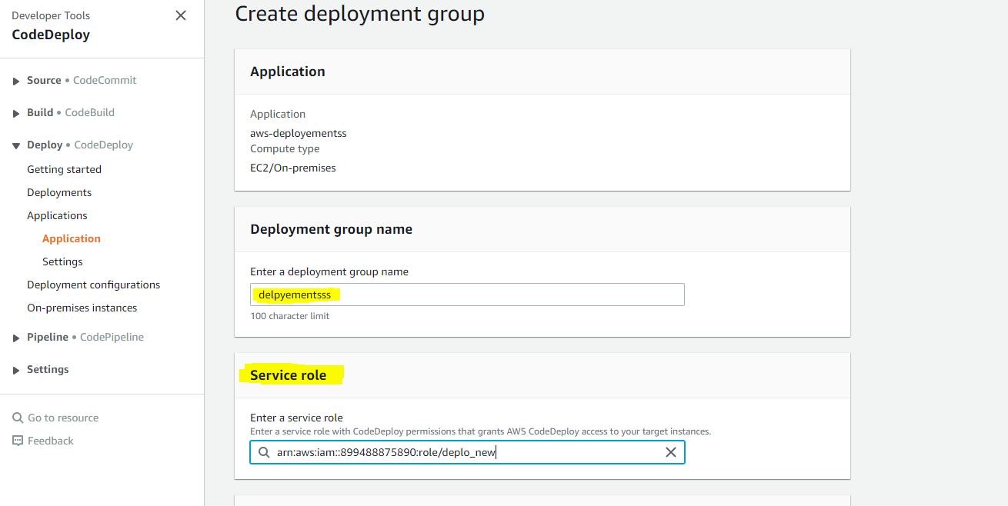

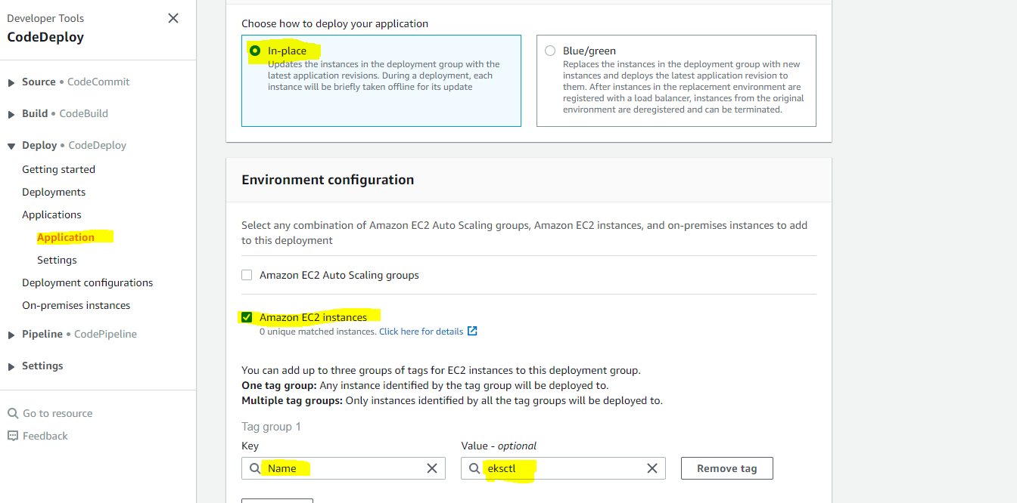

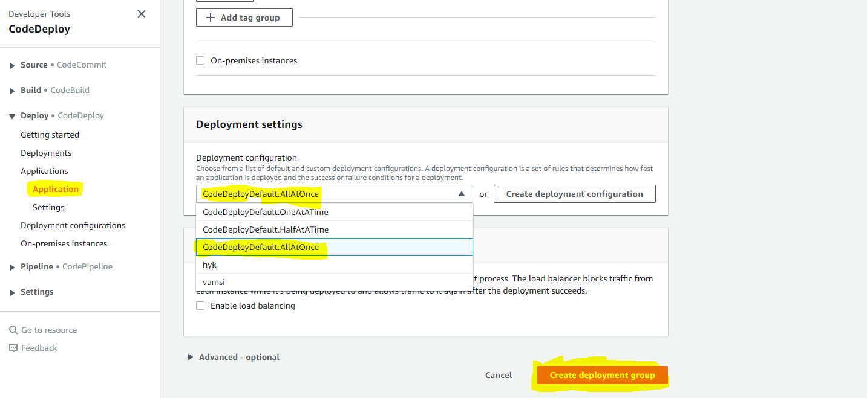

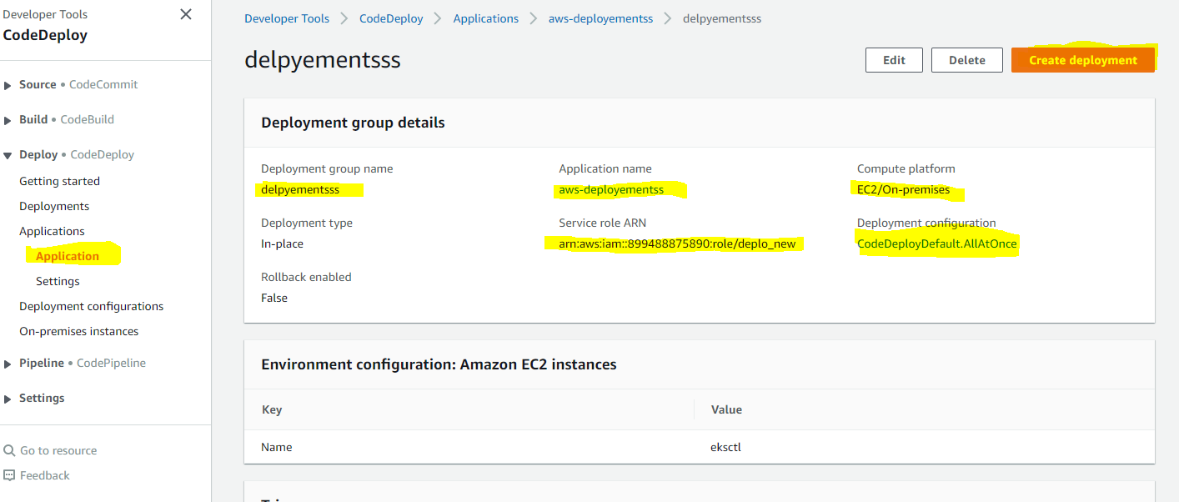

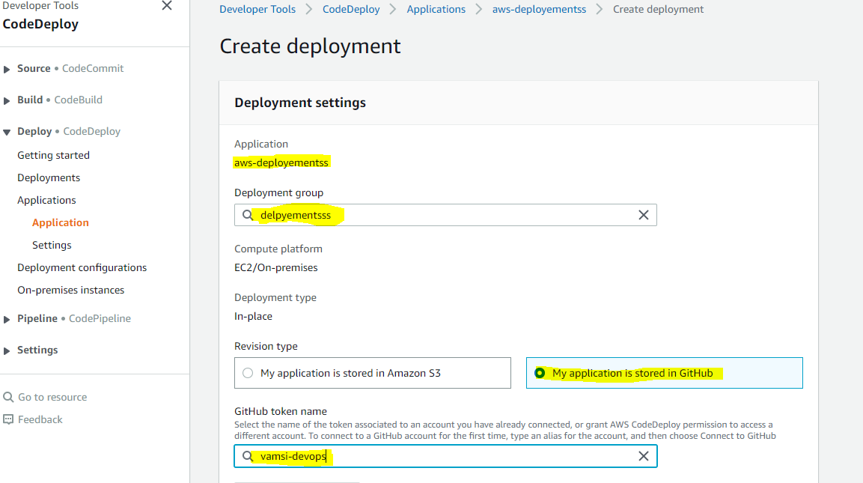

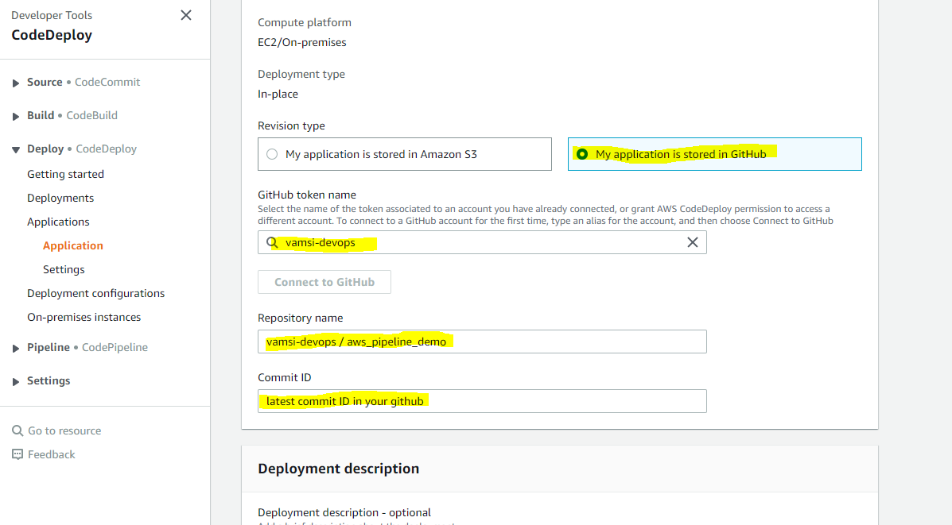

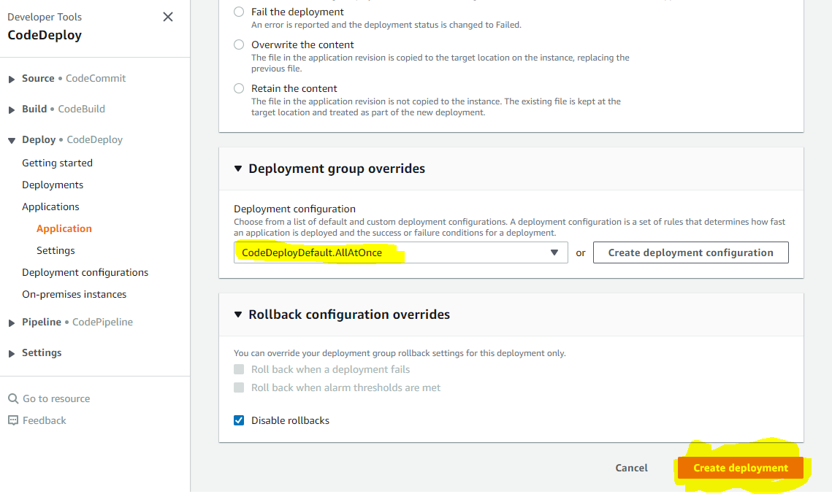

**2.4 Code Pipeline:**

* Now Create a CodePipeline for one click deployment.
* There are three things in Code pipeline.

1) Source 🡪 GitHub is linked to Source

2) Code Build 🡪 buildspec.yml

3) Code Deploy 🡪 appspec.yml

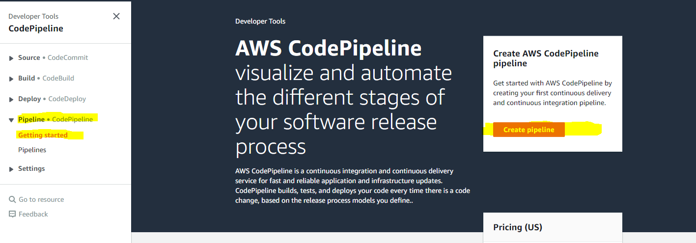

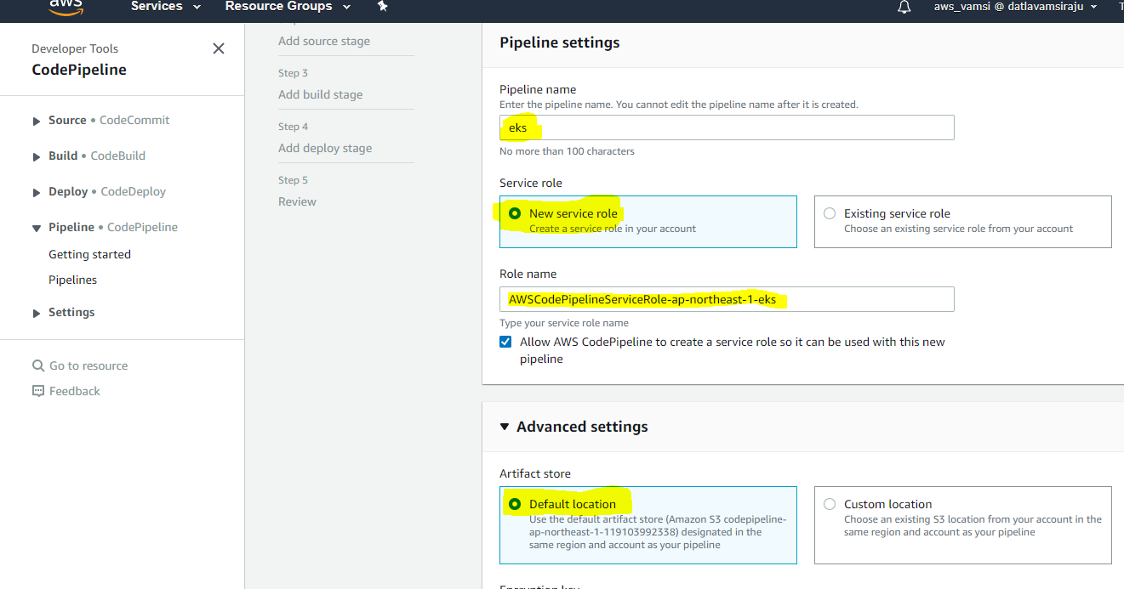



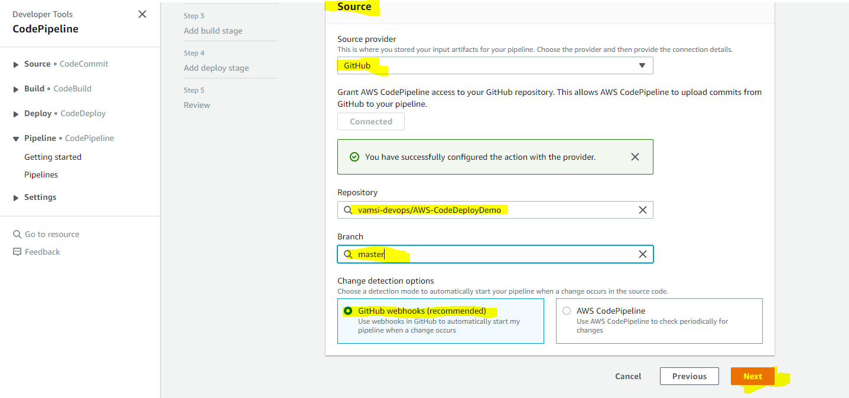

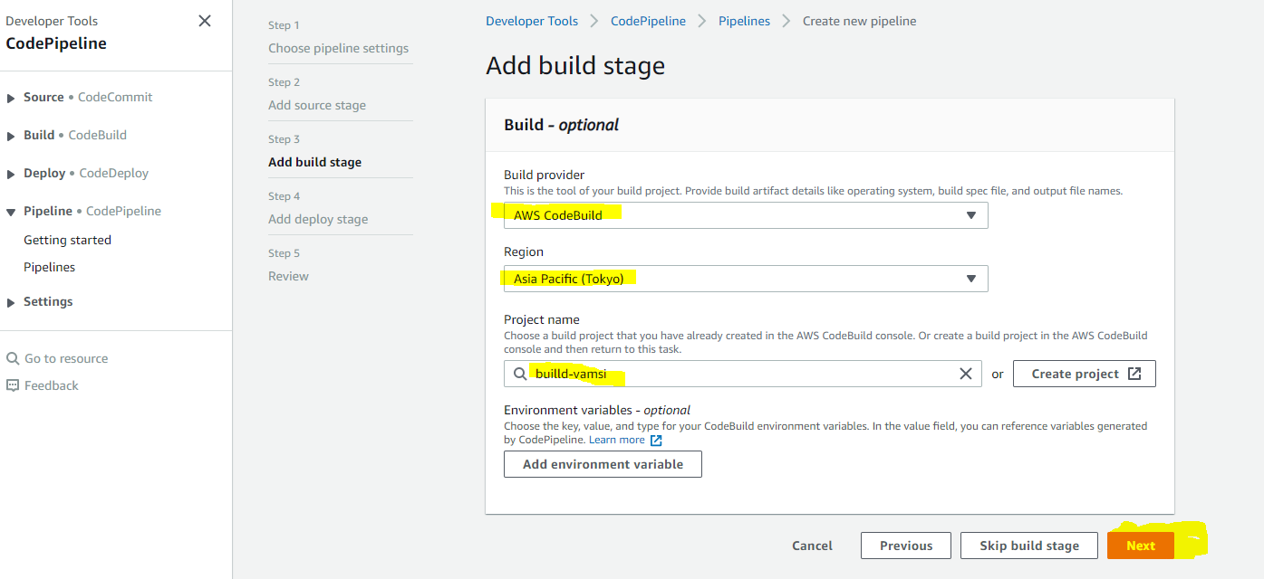

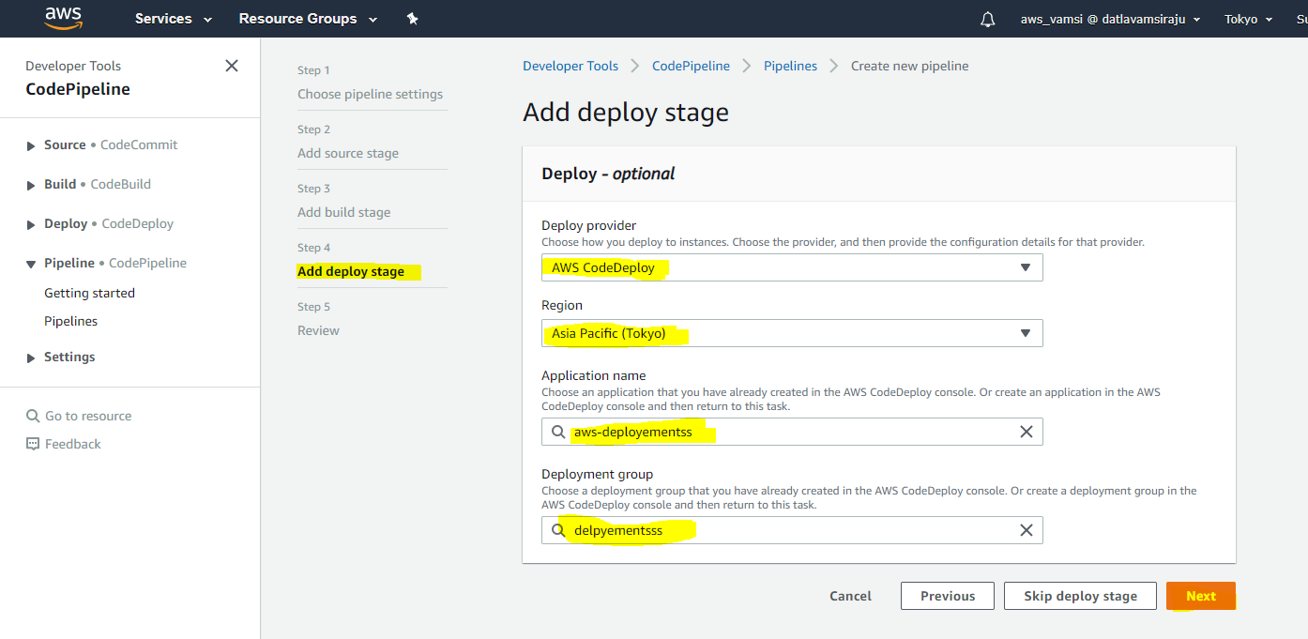



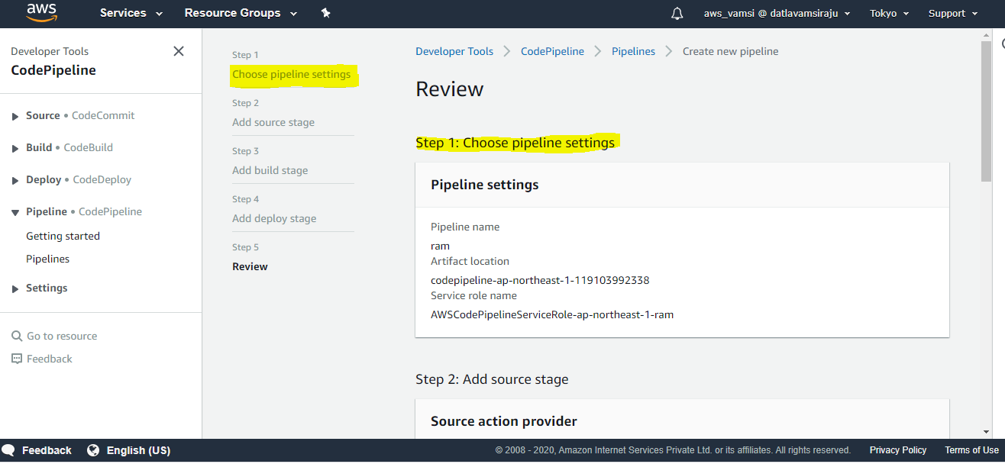



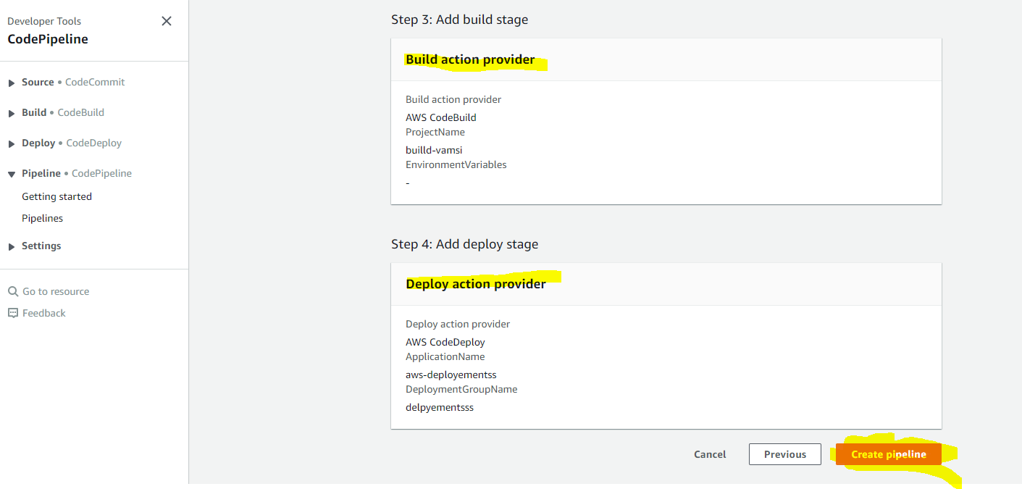

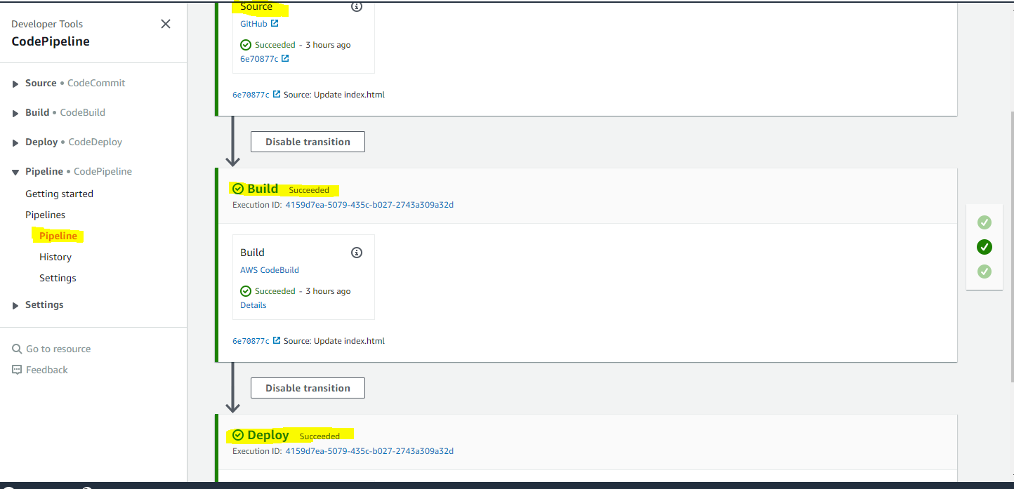

* With the help of below commands we can create a basic-cluster1 these commands are given in appspec.yml.

|  |
| --- |
|  |
|  |  |
|  |  |
|  |  |

The above commands with the help of appspec.yml it will create an EKS cluster.

**2.5 EKS Cluster Formation:**

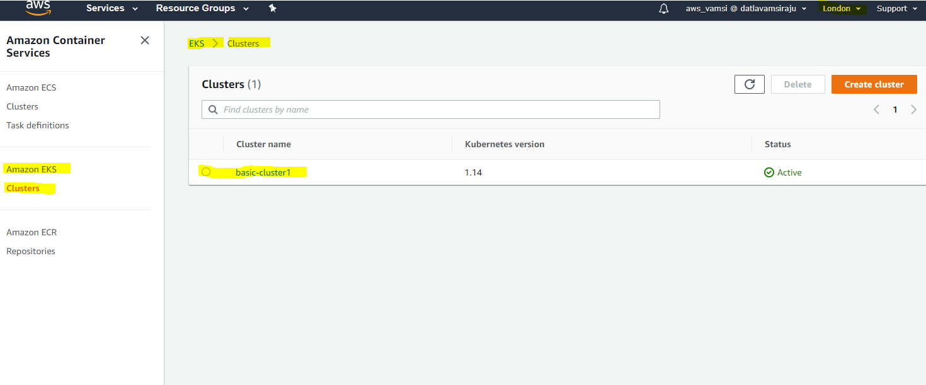



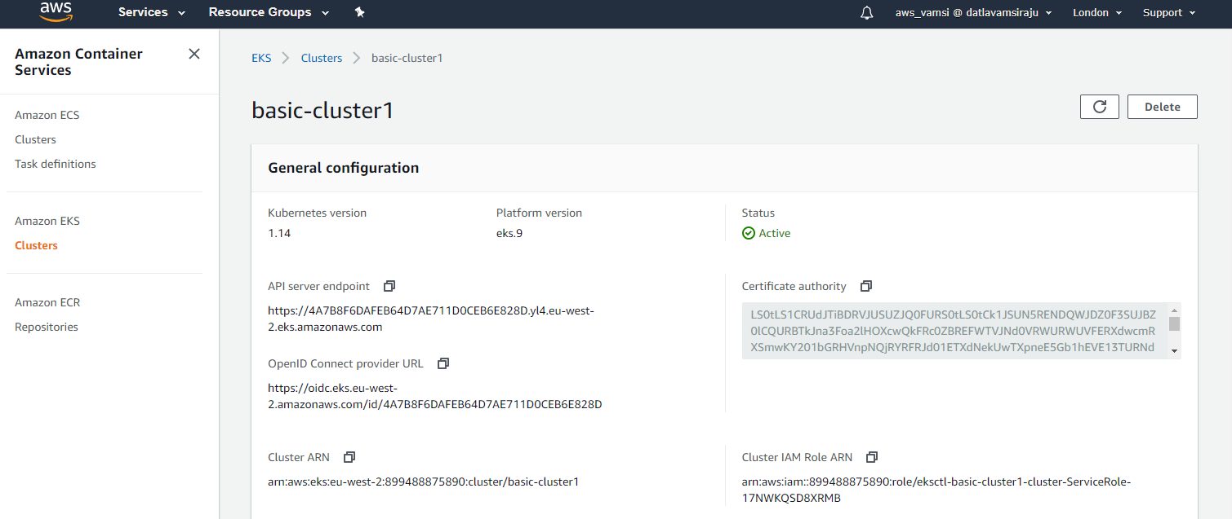



**2.6 Output:**

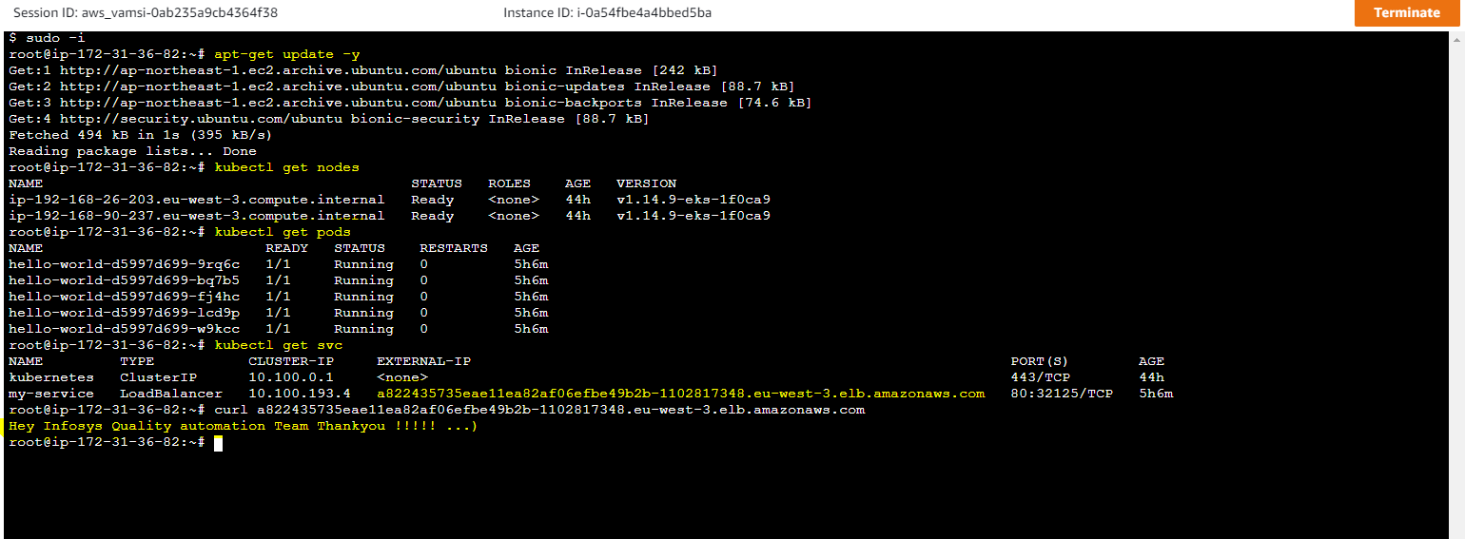



**Reference:**

[https://www.tothenew.com/blog/aws-codedeploy-and-github/#](https://www.tothenew.com/blog/aws-codedeploy-and-github/)

[https://docs.aws.amazon.com/cli/latest/userguide//install-cliv2-linux.html](https://docs.aws.amazon.com/cli/latest/userguide/install-cliv2-linux.html)

<https://docs.aws.amazon.com/codedeploy/latest/userguide/codedeploy-agent-operations-verify.html>

<https://docs.aws.amazon.com/eks/latest/userguide/getting-started-eksctl.html>